# WORKING WITH DATASET

**TEAM MEMBERS**:

SAMUEL AARON K

SRUTHI SRI S C

SUSHMITHAA S

TILAK

# LOADING THE DATASET

|  |  |
| --- | --- |
| Team ID | PNT2022TMID20211 |
| Project Name | Project-Global Sales Data Analytics |

**IBM COGNOS ANALYTICS**: One must connect data to IBM Cognos before can create a view and perform any analysis. Cognos allows users to connect to a wide range of data that is kept in various locations.

# DATASET:

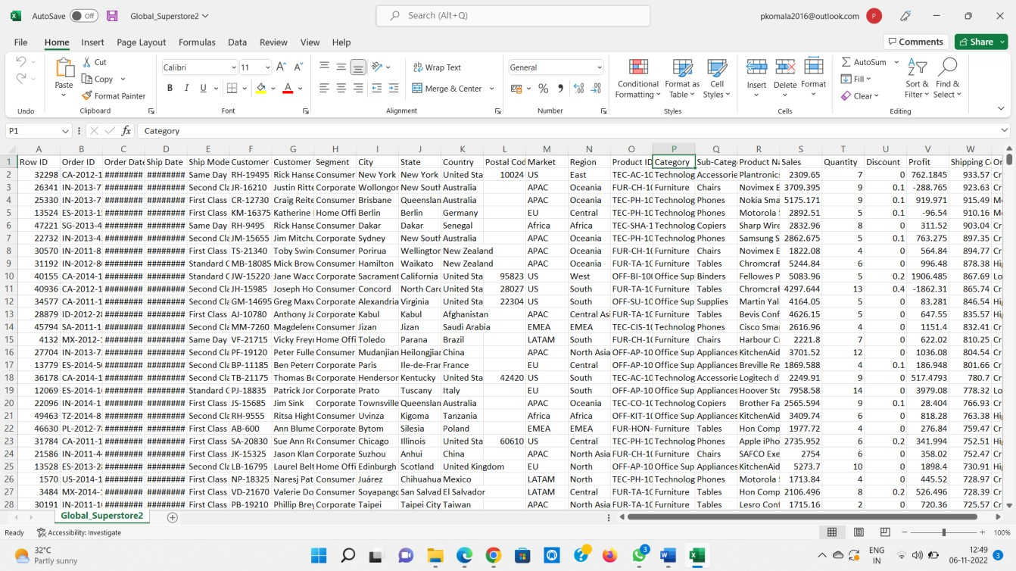

**IBM COGNOS:**

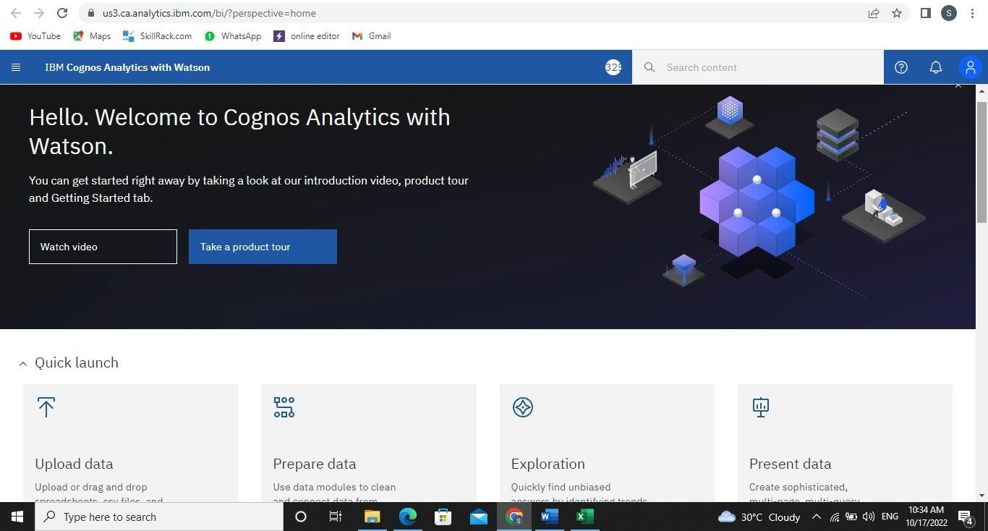

**Uploading the dataset:**

